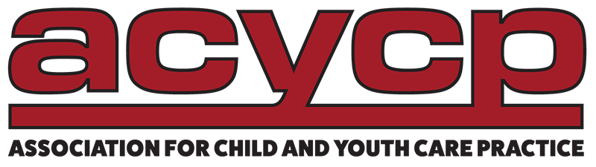

For 45 years, the Association for Child and Youth Care Practice (ACYCP) has worked hard to lift up the recognition, status, and professionalization of child and youth care workers. They have done this primarily through professional Certification, supported by webinars, workshops, trainings and conferences, not to mention awards, scholarships, and media recognition.

Now, ACYCP is reaching out to potential allies in every community of care, with a cost-free reciprocal promotional exchange program, with other social service organizations focused on the welfare of youth, children, and/or families.

Collaborator

◊ Exchange of logos and links to website homepage on respective websites

Partner

◊ Exchange of logos and link to website homepage on respective websites
◊ Exchange of promotional advertisement in newsletters and online periodicals

Associate

◊ Exchange of logos and link to website homepage
◊ Exchange of promotional advertisement in newsletters and online publications
◊ Exchange designation of liaison person for on-going communications
◊ Reciprocal endorsements of respective Mission and Vision Statements

For more details contact us today at:
Michael Mitchell
www.acycp.org
1st VP - ACYCP, Inc.
acycpmembervoicemjm@gmail.com
(608)846-2860
Madison, WI (Central Time)

